Functional Requirement

Specification For

General Settings Module

**Version History:**

|  |  |  |  |
| --- | --- | --- | --- |
| **Version** | **Description of Change** | **Author** | **Date** |
| 1.0 | Draft | Sreeraj | 06/12/18 |
|  |  |  |  |

**Organization**

**Company Profile –**

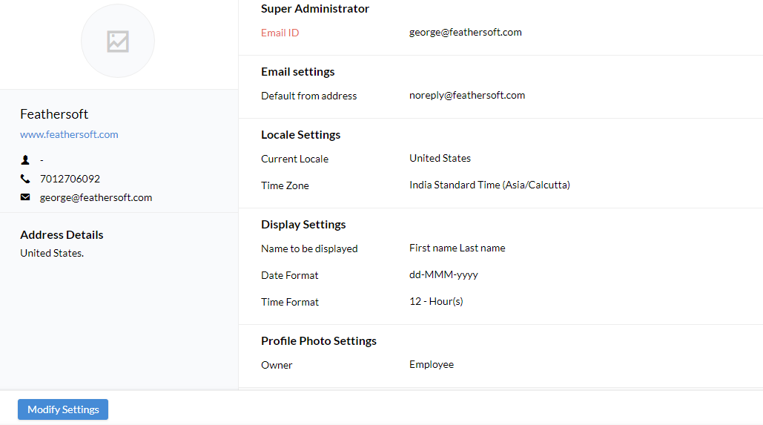

* The company profile will contain some basic information about the organization as shown in reference image above
  + Super administrator
  + Email Settings
  + Location settings
  + Display Settings
  + Profile Photo settings

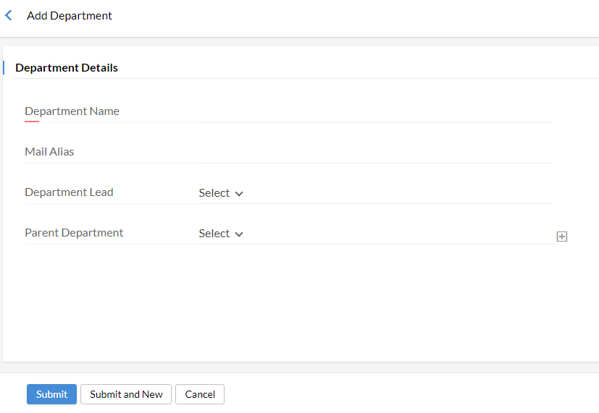**Departments –**

* User can create a new department
* User will be able to view the employees added under the department when selected
* The user can edit/delete a department already added

**Designation –**

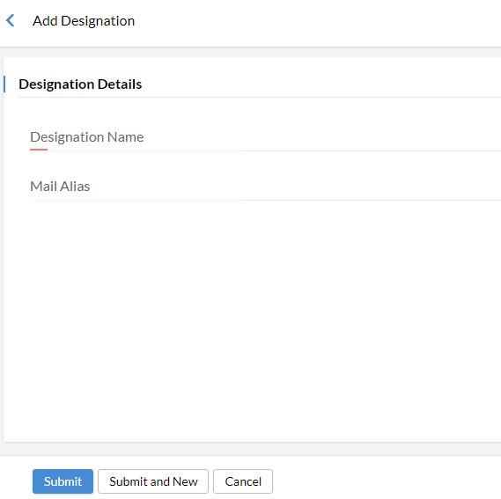

* User can create a new designation by using this section
* Along with the designation, the count of users under it will be shown

**Location -**

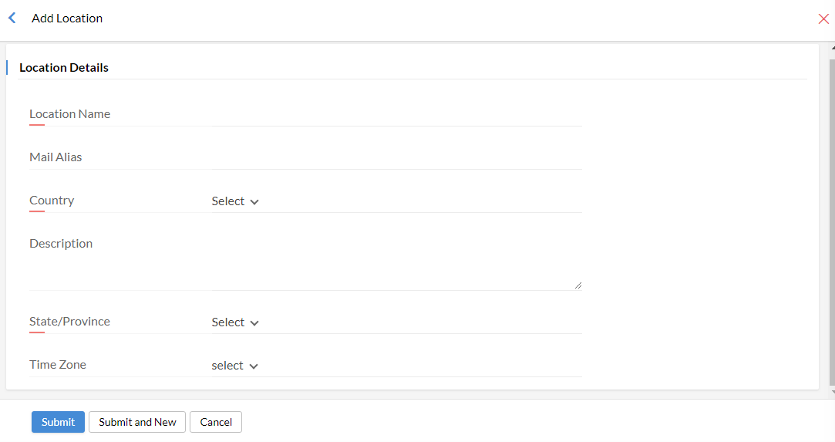

* User can create a new location by using this feature
* User will be able to view the users under the particular location when selected
* Creating different locations will help the user to manage many features like holidays, pay period etc based on location

**Group –**

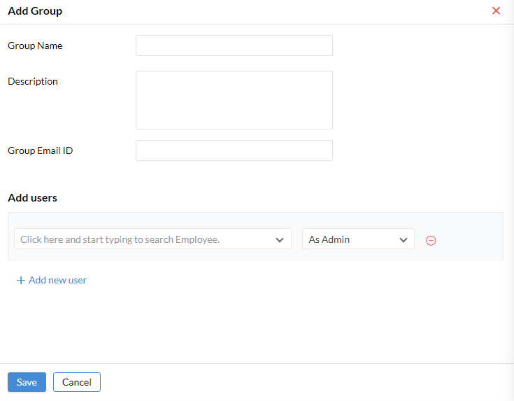

* User can create a user group using this feature
* The group is created to communicate some major information’s with the members in the group

Pay Period Settings & Holiday calendar are explained in leave module

**Employee**

**Users –**

* 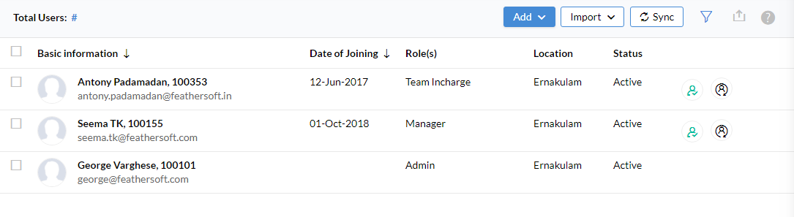The users sections will have the list of users who has access to system
* There is bulk import option to add users to the system
* Single user can also be added by using the add user button
* There is an option to convert a user to employee profile

**Employee Profile –**

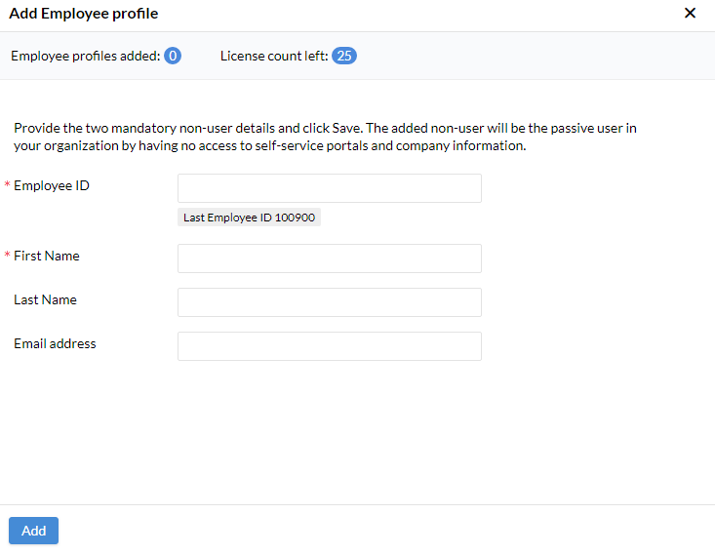

* The employee are those who don’t have access to the system
* The employee should be created with minimum information’s like
  + Employee ID
  + First Name
  + Last Name
  + Email Address

**Pay Period Settings –**

* Can configure a pay period using this feature
* The basic information’s required to configure a pay period are: -
  + Pay Period Name
  + Pay Period Cycle
  + Processing Day
  + Lock – option to prevent any further modification after specified date
  + Applicable Location

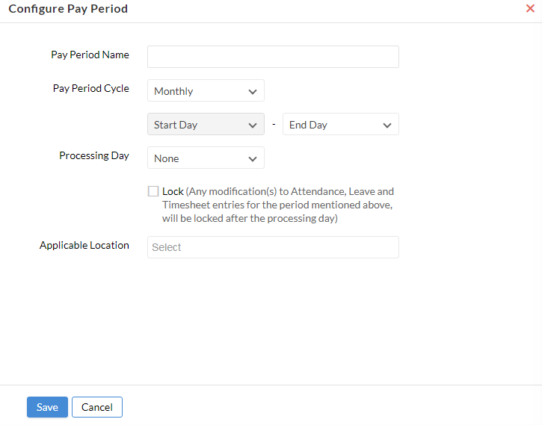

**Calendar Settings –**

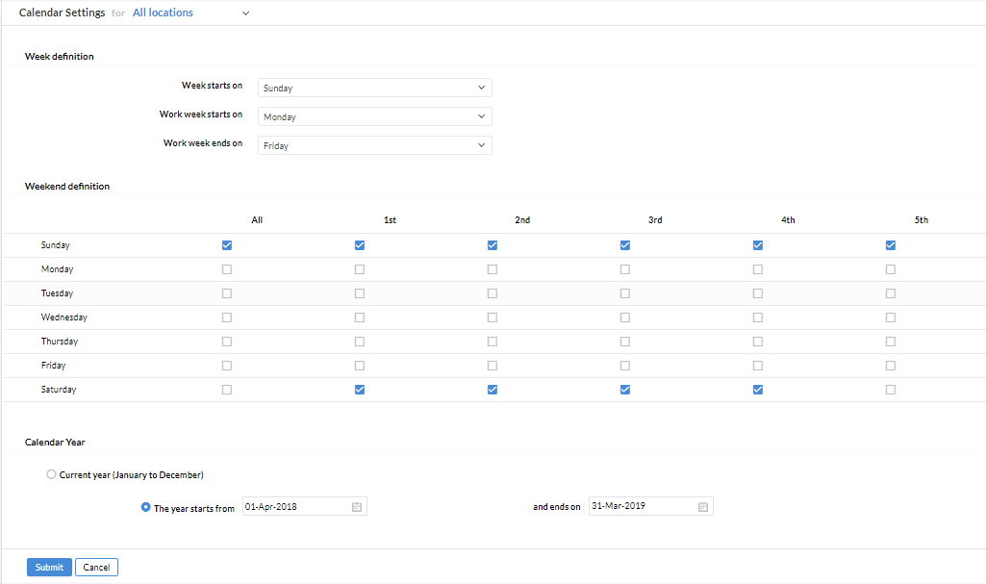

* Admin has the provision to set calendar for the year
* There will be a section named ‘Week definition’ where the user can set
  + Week Start On
  + Work Week Start On
  + Work Week Ends On
* There will be an another section named ‘Weekend definition’ where user can manage the weekend
* There is also a setting named ‘Calendar year’ where the user can mention the start and end of the year
* The user can define whether this calendar setting is for a particular location or for all locations and also for a category(Gen/Dev)

**Manage Holidays –**

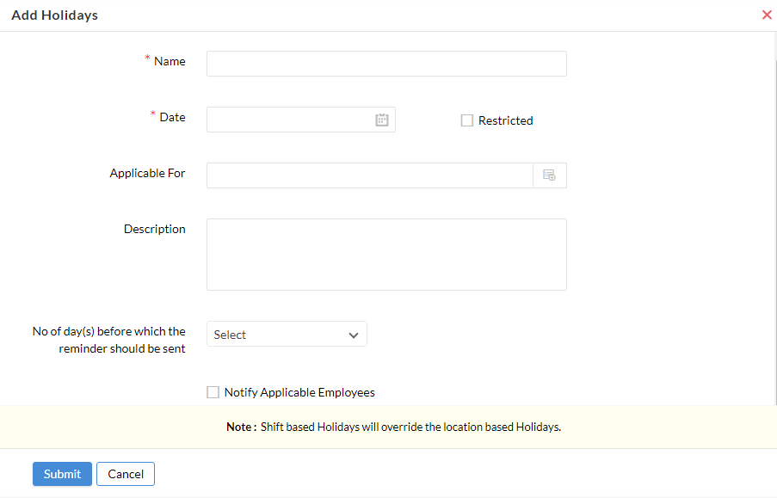

* Name – Name of the holiday
* Date – Pick the date from the calendar
* Restricted – Option to mark it as a restricted holiday
* Applicable For – Option to select users to which the holiday is applicable for
* Description – Option to provide a description for the holiday (if needed)
* Reminder – Option to set a reminder for the holiday and also have an option to notify applicable employees

**Exception Working days –**

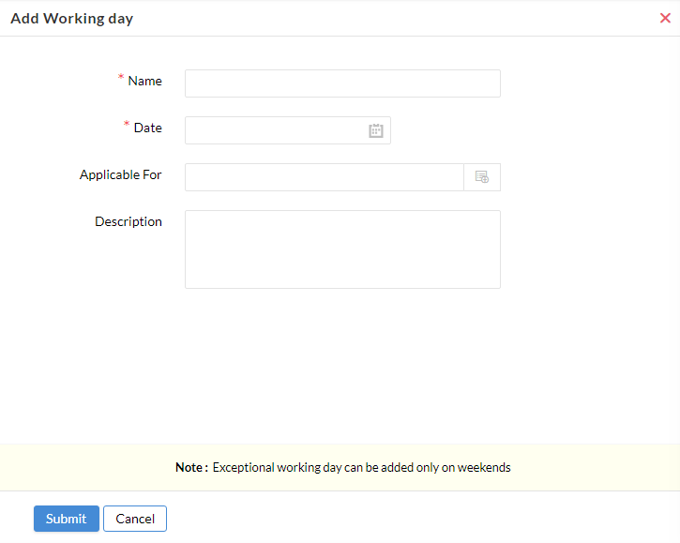

Can create an exceptional working day by using this feature by just providing

* + Name
  + Date
  + Applicable For
  + Description
* The exceptional working day can only be added on weekends

**User Access Control**

**Roles –**

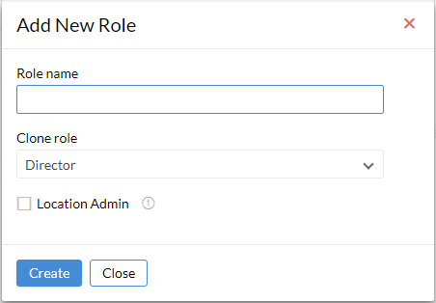

* The user can create a new role using this section
* The user can provide a role name and can select a role from the drop down
* User can set a location admin who will be admin for all modules except performance module
* User will be able to see the users under the role when selected
* User can either edit/delete a role which is already added

**Permissions –**

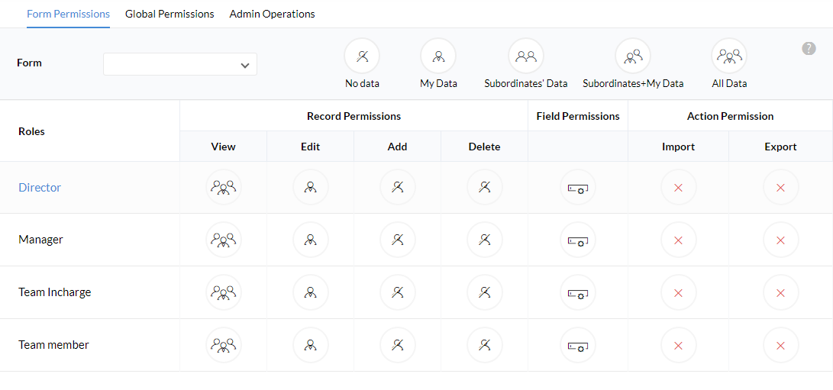

* The permissions to different roles can be managed through this module

**Allowed IPs –**

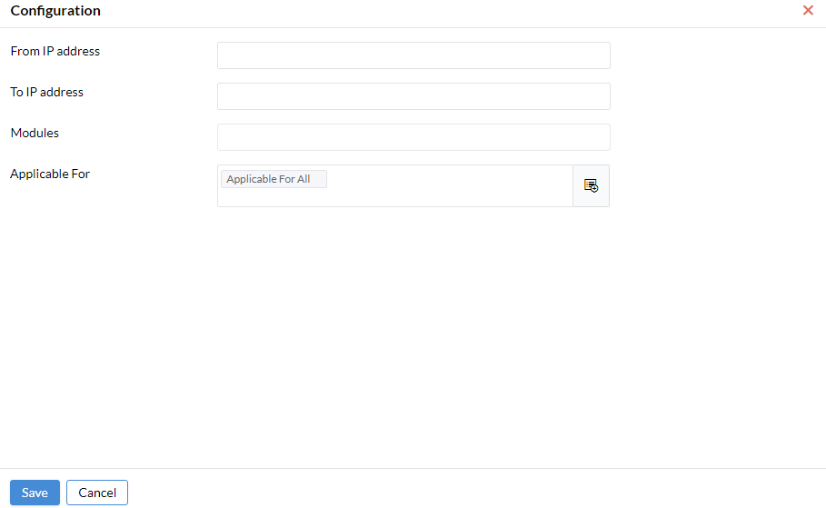

* The user can configure IP address for different modules for different users by using this section